**ABHIJIT DASH**

**RA1811031010112**

**COMPUTATION OF LR(0) ITEMS**

**AIM:-**

To write a program for Computation of LR (0) items.

**CODE:-**

gram = {

"S":["CC"],

"C":["aC","d"]

}

start = "S"

terms = ["a","d","$"]

non_terms = []

for i in gram:

non_terms.append(i)

gram["S'"]= [start]

new_row = {}

for i in terms+non_terms:

new_row[i]=""

non_terms += ["S'"]

# each row in state table will be dictionary {nonterms ,term,$}

stateTable = []

# I = [(terminal, closure)]

# I = [("S","A.A")]

def Closure(term, I):

if term in non_terms:

for i in gram[term]:

I+=[(term,"."+i)]

I = list(set(I))

for i in I:

# print("." != i[1][-1],i[1][i[1].index(".")+1])

if "." != i[1][-1] and i[1][i[1].index(".")+1] in non_terms and i[1][i[1].index(".")+1] != term:

I += Closure(i[1][i[1].index(".")+1], [])

return I

Is = []

Is+=set(Closure("S'", []))

countI = 0

omegaList = [set(Is)]

while countI<len(omegaList):

newrow = dict(new_row)

vars_in_I = []

Is = omegaList[countI]

countI+=1

for i in Is:

if i[1][-1]!=".":

indx = i[1].index(".")

vars_in_I+=[i[1][indx+1]]

vars_in_I = list(set(vars_in_I))

# print(vars_in_I)

for i in vars_in_I:

In = []

for j in Is:

if "."+i in j[1]:

rep = j[1].replace("."+i,i+".")

In+=[(j[0],rep)]

if (In[0][1][-1]!="."):

temp = set(Closure(i,In))

if temp not in omegaList:

omegaList.append(temp)

if i in non_terms:

newrow[i] = str(omegaList.index(temp))

else:

newrow[i] = "s"+str(omegaList.index(temp))

print(f'Goto(I{countI-1},{i}):{temp} That is I{omegaList.index(temp)}')

else:

temp = set(In)

if temp not in omegaList:

omegaList.append(temp)

if i in non_terms:

newrow[i] = str(omegaList.index(temp))

else:

newrow[i] = "s"+str(omegaList.index(temp))

print(f'Goto(I{countI-1},{i}):{temp} That is I{omegaList.index(temp)}')

stateTable.append(newrow)

print("\n\nList of I's\n")

for i in omegaList:

print(f'I{omegaList.index(i)}: {i}')

#populate replace elements in state Table

I0 = []

for i in list(omegaList[0]):

I0 += [i[1].replace(".","")]

print(I0)

for i in omegaList:

for j in i:

if "." in j[1][-1]:

if j[1][-2]=="S":

stateTable[omegaList.index(i)]["$"] = "Accept"

break

for k in terms:

stateTable[omegaList.index(i)][k] = "r"+str(I0.index(j[1].replace(".","")))

print("\nStateTable")

print(f'{" ": <9}',end="")

for i in new_row:

print(f'|{i: <11}',end="")

print(f'\n{"-":-<66}')

for i in stateTable:

print(f'{"I("+str(stateTable.index(i))+")": <9}',end="")

for j in i:

print(f'|{i[j]: <10}',end=" ")

print()

**OUTPUT SCREENSHOTS:-**

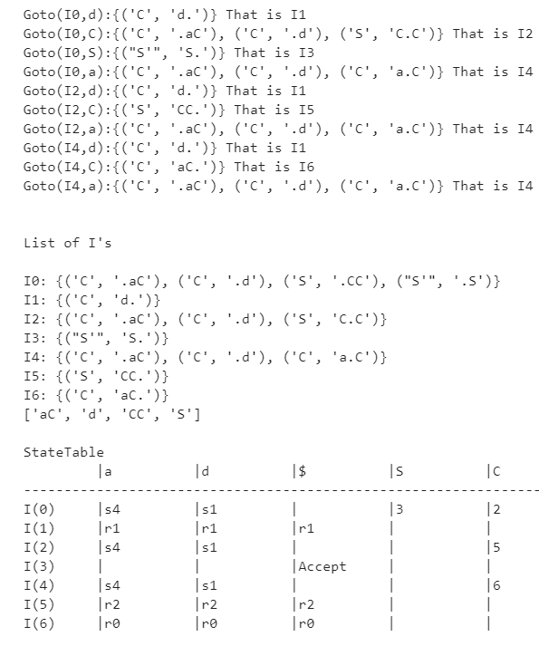

**RESULT:-**

Thus LR(0) table is created from the given input in the code.